**How To Install IIS In Windows Server 2016**

Posted by [Jarrod](https://www.rootusers.com/author/jarrod/) on August 24, 2016[Leave a comment](https://www.rootusers.com/how-to-install-iis-in-windows-server-2016/#respond) (5)[Go to comments](https://www.rootusers.com/how-to-install-iis-in-windows-server-2016/" \l "comments" \o "Go to comments ?)

Here we’re going to show you how to install the Internet Information Services (IIS) web server version 10.0 in Microsoft’s Windows Server 2016 operating system.

This can be done both with PowerShell or through the GUI, we’ll cover both methods here.

**Install IIS With PowerShell**

If you don’t have the GUI installed or just want to use the PowerShell command line interface (CLI) instead, follow these steps. This method is a lot faster than going through all of the GUI options.

1. Open PowerShell with administrative privileges and run the Install-WindowsFeature cmdlet as shown below.
2. Install-WindowsFeature -name Web-Server -IncludeManagementTools

[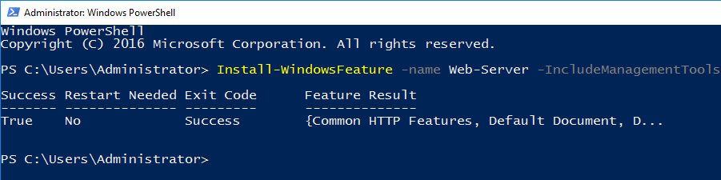](https://www.rootusers.com/wp-content/uploads/2016/08/powershell-install-iis.png)

Here we include the management tools so that you can manage IIS on this server, as these are generally installed when using the GUI, making this PowerShell command equivalent with the GUI method below. If you do not plan on managing IIS through this server then you may prefer to not include this option.

1. Once the installation has succeeded, you’ll be returned to the PowerShell prompt. At this point IIS should be running on port 80 by default with the firewall rule “World Wide Web Services (HTTP Traffic-In)” enabled in Windows firewall automatically.
2. We can perform a simple test by opening up a web browser and browsing to the server that we have installed IIS on. You should see the default IIS page.

[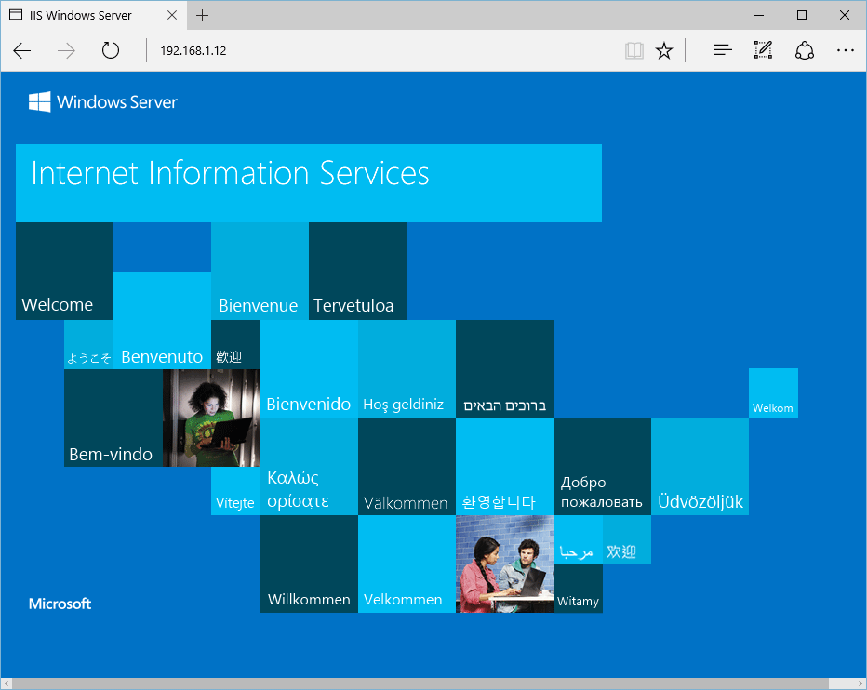](https://www.rootusers.com/wp-content/uploads/2016/08/default-iis-website.png)

**Install IIS Through GUI**

If your server has the graphical user interface component installed you can also install IIS by following these steps.

1. Open Server Manager, this can be found in the start menu. If it’s not there simply type “Server Manager” with the start menu open and it should be found in the search.

[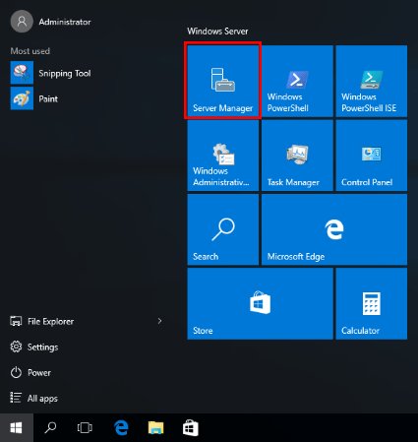](https://www.rootusers.com/wp-content/uploads/2016/08/server-manager-windows-2016.png)

1. Click the “Add roles and features” text.

[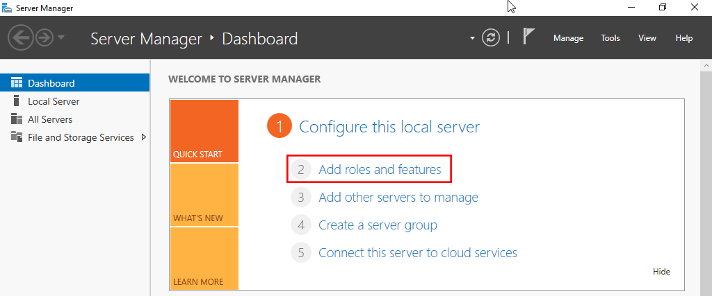](https://www.rootusers.com/wp-content/uploads/2016/08/server-manager-add-roles-and-features-2016.png)

1. On the “Before you begin” window, simply click the Next button.

[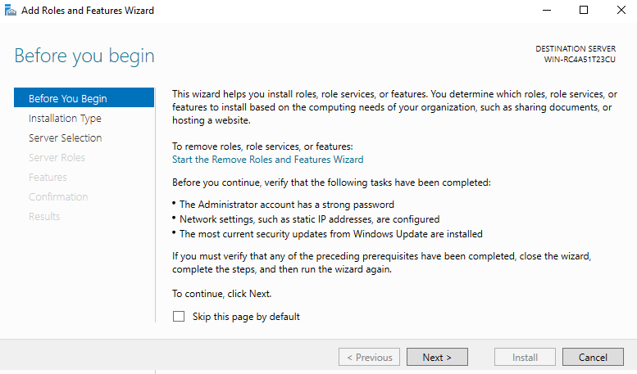](https://www.rootusers.com/wp-content/uploads/2016/08/server-manager-windows-2016-2.png)

1. On the “Select installation type” window, leave “Role-based or feature-based installation” selected and click Next.

[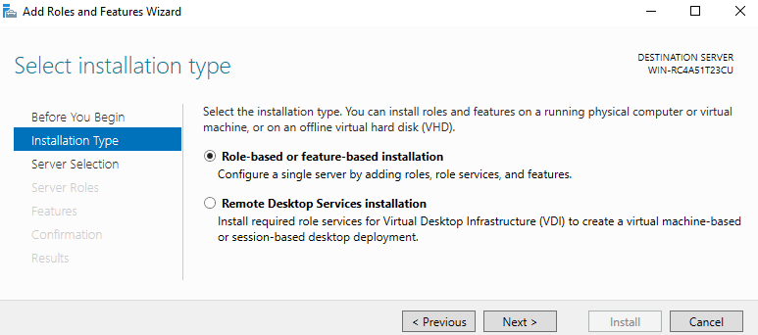](https://www.rootusers.com/wp-content/uploads/2016/08/server-manager-windows-2016-3.png)

1. As we’re installing to our local machine, leave “Select a server from the server pool” with the current machine selected and click Next. Alternatively you can select another server that you are managing from here, or a VHD.

[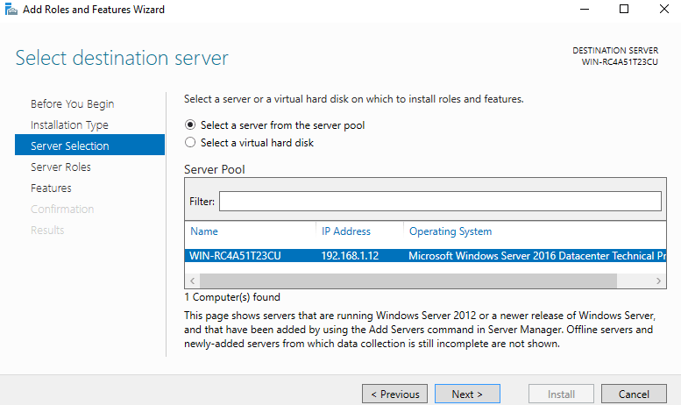](https://www.rootusers.com/wp-content/uploads/2016/08/server-manager-windows-2016-4.png)

1. From the “Select server roles” window, check the box next to “Web Server (IIS)”. Doing this may open up a new window advising that additional features are required, simply click the “Add Features” button to install these as well. Click Next back on the Select server roles menu once this is complete.

[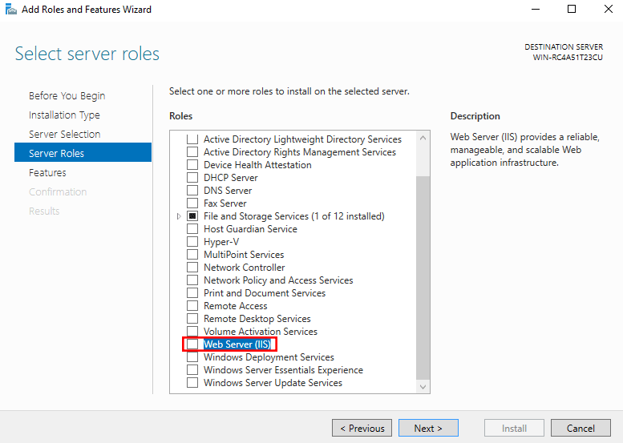](https://www.rootusers.com/wp-content/uploads/2016/08/server-manager-windows-2016-5.png)

[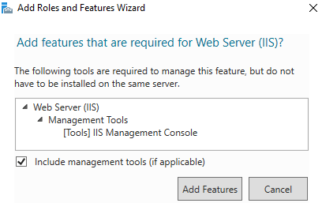](https://www.rootusers.com/wp-content/uploads/2016/08/server-manager-windows-2016-6.png)

1. We will not be installing any additional features at this stage, so simply click Next on the “Select features” window.

[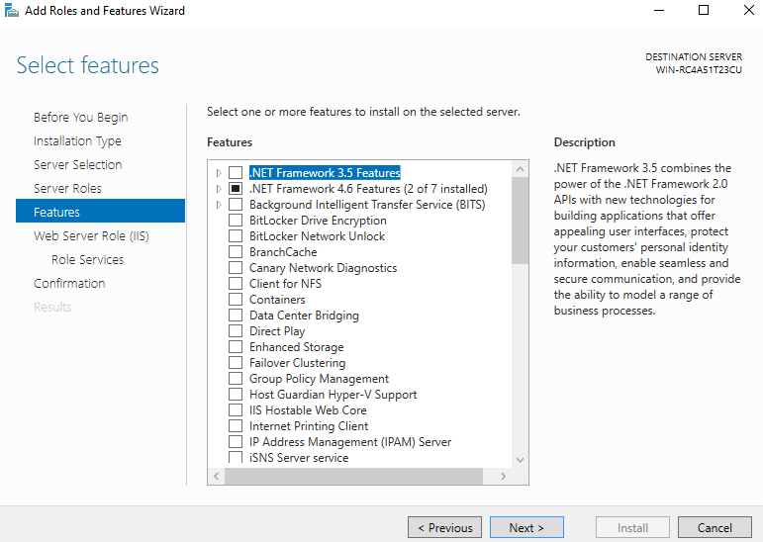](https://www.rootusers.com/wp-content/uploads/2016/08/server-manager-windows-2016-7.png)

1. Click Next on the “Web Server Role (IIS)” window after reading the information provided.

[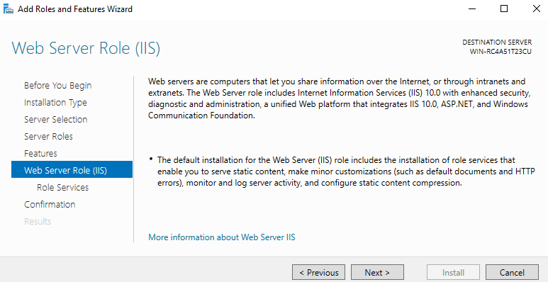](https://www.rootusers.com/wp-content/uploads/2016/08/server-manager-windows-2016-8.png)

1. At this point on the “Select role services” window you can install additional services for IIS if required. You don’t have to worry about this now as you can always come back and add more later, so just click Next for now to install the defaults.

[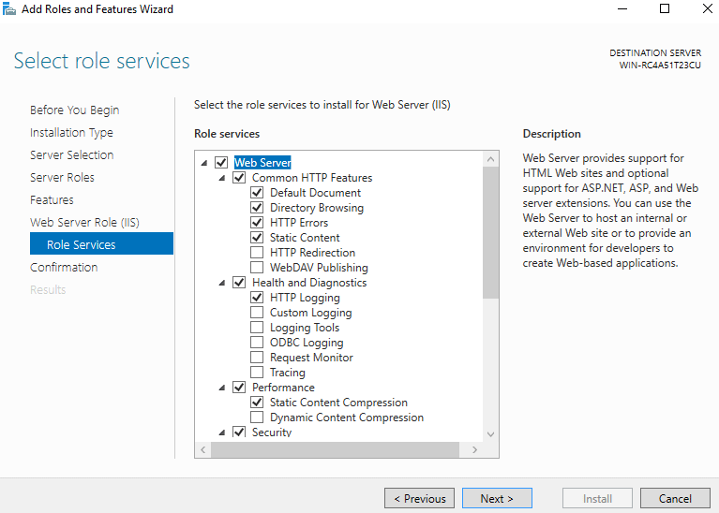](https://www.rootusers.com/wp-content/uploads/2016/08/server-manager-windows-2016-9.png)

1. Finally on the “Confirm installation selections” window , review the items that are to be installed and click Install when you’re ready to proceed with installing the IIS web server.

[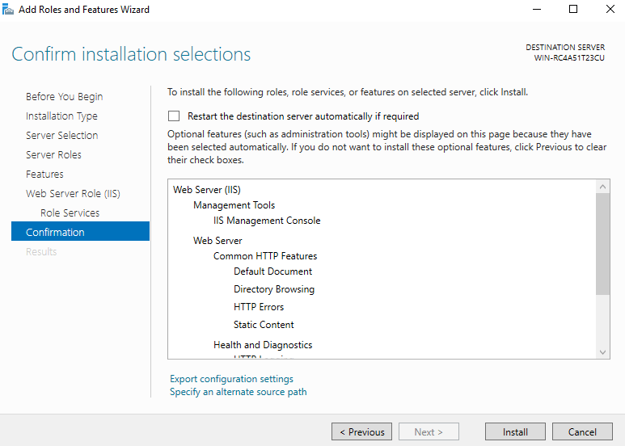](https://www.rootusers.com/wp-content/uploads/2016/08/server-manager-windows-2016-10.png)

No reboot should be required with a standard IIS installation, however if you remove the role a reboot will be needed.

1. Once the installation has succeeded, click the close button. At this point IIS should be running on port 80 by default with the firewall rule “World Wide Web Services (HTTP Traffic-In)” enabled in Windows firewall automatically.

[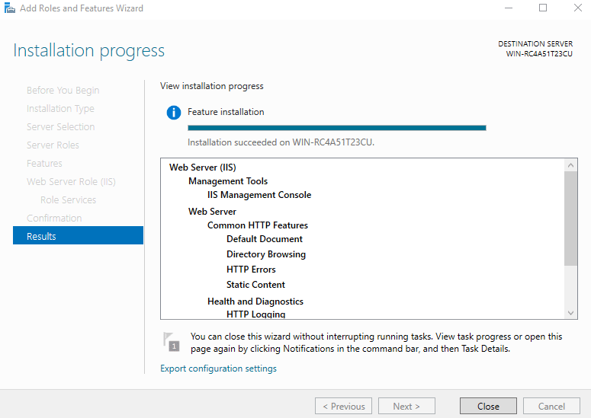](https://www.rootusers.com/wp-content/uploads/2016/08/server-manager-windows-2016-11.png)

1. We can perform a simple test by opening up a web browser and browsing to the server that we have installed IIS on. You should see the default IIS page.

[](https://www.rootusers.com/wp-content/uploads/2016/08/default-iis-website.png)